# Advanced Data Visualization – Lab #4

|  |  |
| --- | --- |
| Provided file(s): | * Lab06.docx * Global Superstore.xls |
| Submission file(s): | * Lab06.docx * Lab06.twb |

Work in your groups. Only one member of your group should submit. Only the last submission from before the deadline will be marked.

## Dashboards

From a Tableau perspective, a **dashboard** is an arrangement of individual visualizations, along with other components such as legends, filters, parameters, text, containers, images, extensions, buttons, and web objects that are arranged on a single canvas. Ideally, the visualizations and components should work together to tell a complete and compelling data story. Dashboards are often, but not always, interactive.

Create an empty dashboard tab

Create or Open a new dashboard tab like opening a new worksheet. You can click the **New Dashboard** icon at the bottom of the workbook, indicated by the box divided into four sections



## Objects

Dashboards are made up of objects that are arranged on a canvas. You'll see a list of objects that can be added to a dashboard in the left-hand pane of a dashboard:

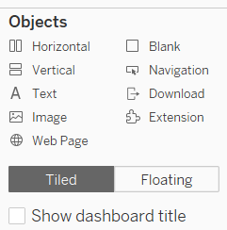

In addition to the objects that you can add through the sidebar, there are other objects that may be applicable to a given dashboard:

* **Filters**: These will appear as controls for the end user so that they can select values to filter. The power of a dashboard is the ability to set up filters and interactive components to change the data in the visualization to ultimately enhance your users' analysis. In a dashboard, a good rule to follow is to organize the filters as a list on the right side of the dashboard.

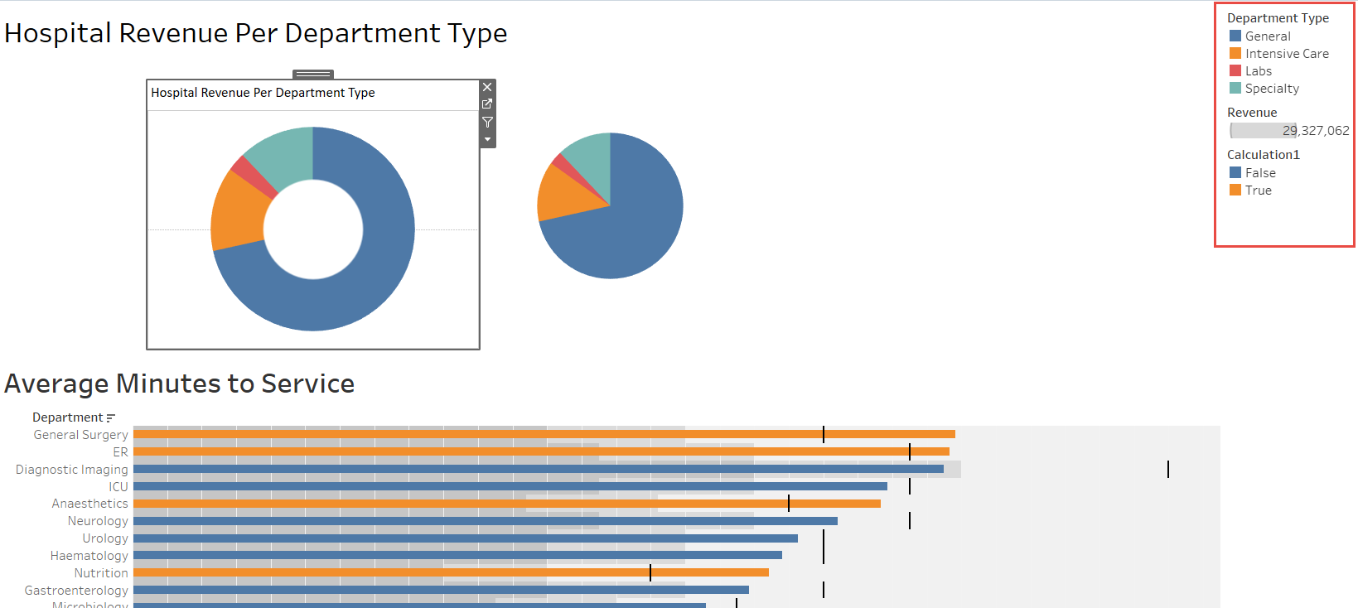

* **Parameters**: Like filters, these will show up as controls for the end user to select a parameter option
* **Page controls**: These are controls that give the end user options for paging through the data
* **Legends**: These include color, size, and shape legends to help the end user understand various visualizations
* **Highlighters**: These allow the user to highlight various dimension values within views
* **Dashboard title**: A special text object that displays the name of the dashboard sheet by default

## Adding Worksheet Visualizations

Once a dashboard sheet is created, click the worksheet views you built (listed under **Sheets** to the left) and drag them to your dashboard sheet on the right. A gray, shaded area indicates where you can drop your visualization:

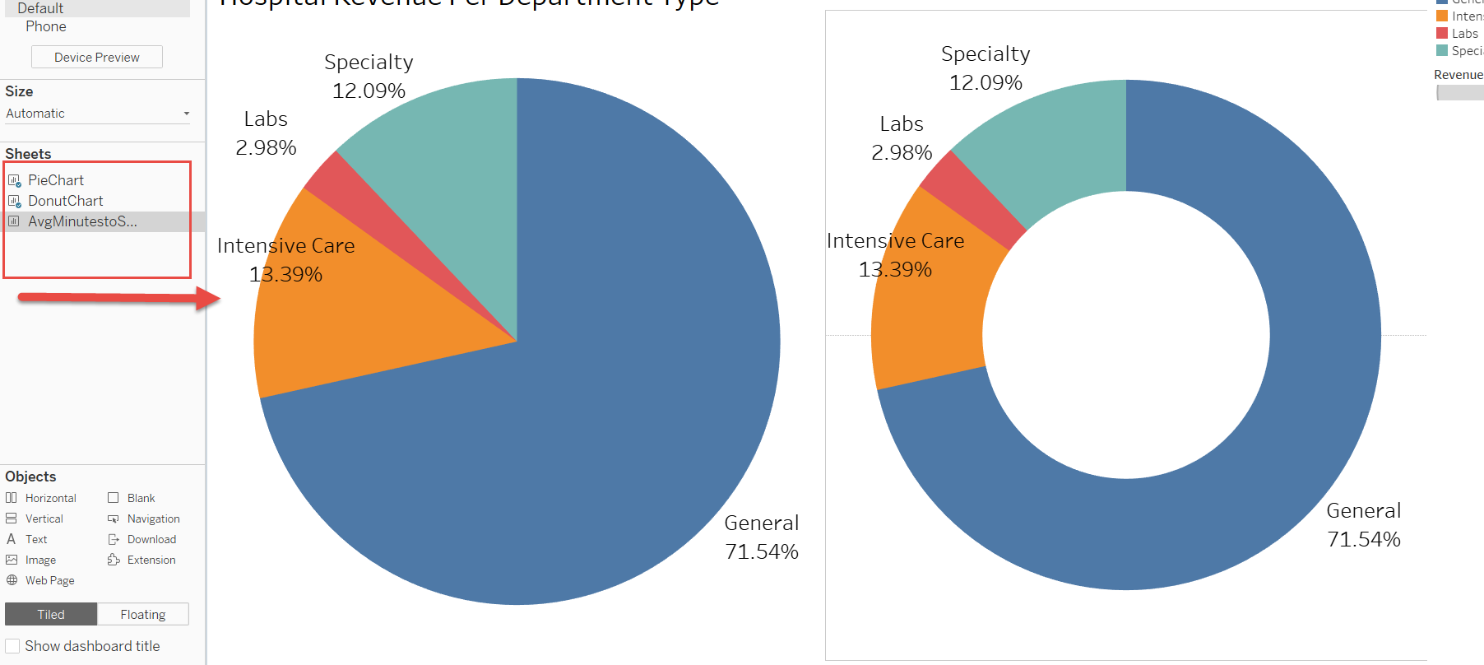

Tiled vs. Floating Objects

* **Tiled:** Tiled visualizations become part of a single-layer grid that resizes based on the dashboard size. Pairs well with the automatic canvas selection. **Tiled visualizations do not overlap.** 
  + **If it is a tiled object, it will snap into the dashboard or layout container where you drop it.**
* **Floating:** Free-floating visualizations that can be layered over other objects. Equivalent to Microsoft Word Wrap Text: In front of text.
  + If it is a floating object, it will float over the dashboard in layers.
* In the example below, a DonutChart floats over tiled visualizations:

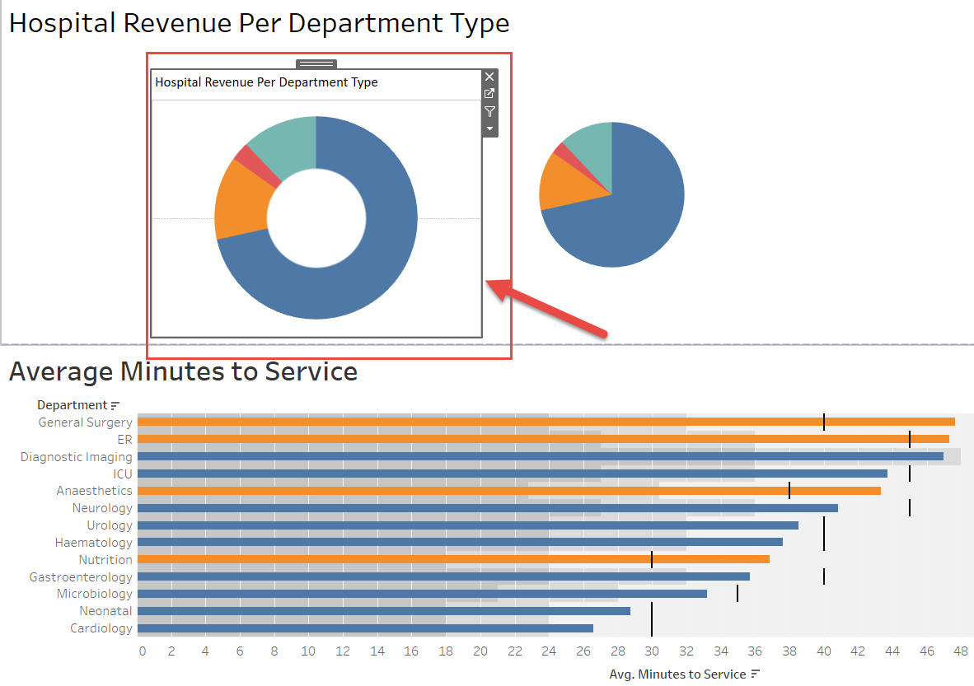

Part I: Overall Profit by Category

1. Download **Superstore.xlsx** from Blackboard.
2. Open Tableau Desktop, and then connect to the Microsoft Excel file.
3. Create New Sheet, name it as “**Overall Profit by Category**”
4. Create a bar chart showing **Profit** by **Category**. Sort the categories in descending order by the Sum of Profit.
5. Copy and Paste the created dashboard **Overall Profit by Category** here:

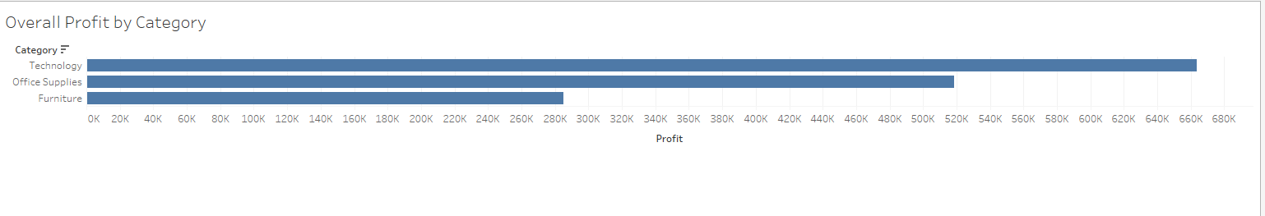

1. Save your tableau file as **LAB06.twbx**.

Part II: Top 10 Least Profitable Items

1. Create New Sheet, name it as “**Top 10 Least Profitable Items**”
2. Create a bar chart showing **Profit** by **Product Name**. Sort in descending order A graph with a arrow pointing down

   AI-generated content may be incorrect. by Sum(Profit).
3. You'll notice that there are too many items to see at one time. For your objectives on this dashboard, you can limit the items to only the top 10 least profitable. Right-click **Product Name**, choose **Filter…**, and select the **Top** tab, and adjust the settings to **Filter By Field**. Specify the **Bottom** 10 by **Profit Sum**. Click **OK**.
4. Resort in descending order.
5. Copy and Paste the created dashboard **Top 10 Least Profitable Items** here:  
   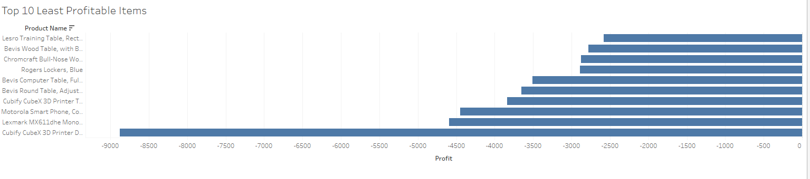
6. Save your Tableau file.

Part III: Profit by State

1. Create **New Sheet**, name it as “**Profit by State**”
2. Create a filled map of **Profit** by **State**. You can accomplish this rather quickly by double-clicking the **State** field in the data window and then dropping **Profit** on the Color card.
3. Click the “X unknown” error and change the location if you wish (or leave it at the default location).
4. Copy and Paste the created dashboard **Profit by State** here:

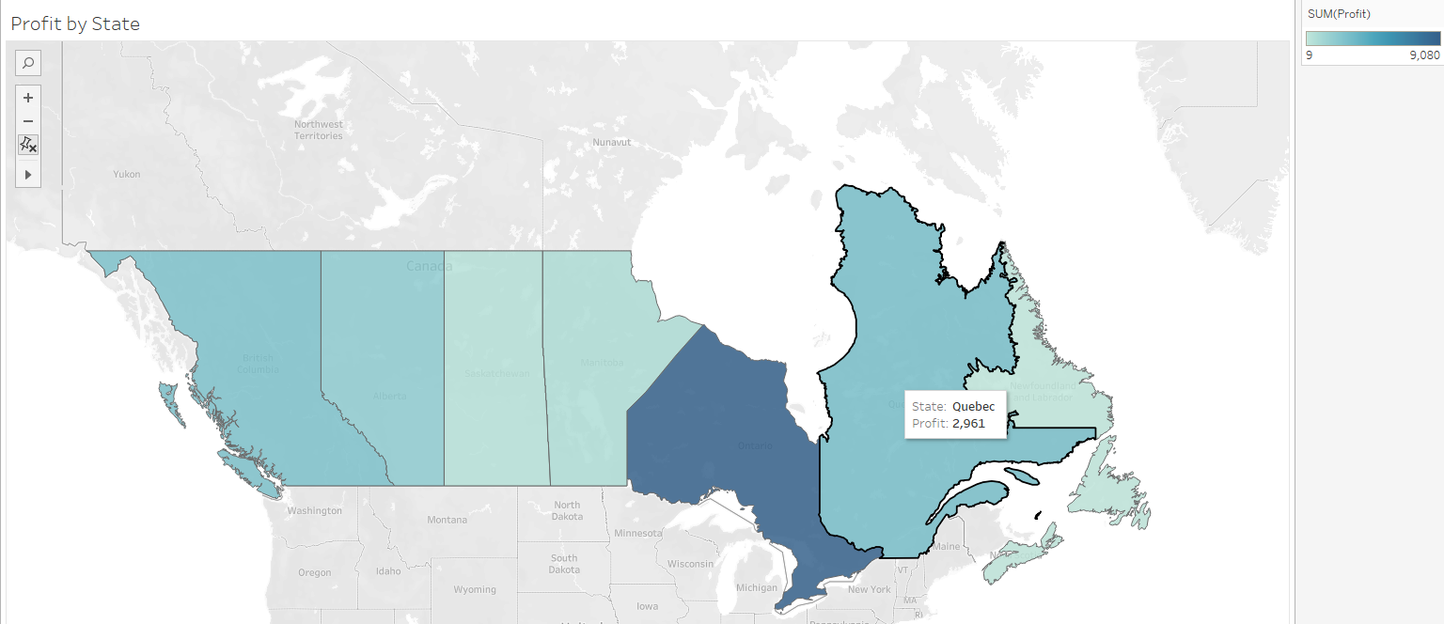

1. Save your tableau file.

Part IV: Profit Trend

1. Create New Sheet, name it as “**Profit Trend**”
2. Create chart shows profits were made or lost. Ensure that the **Order Date** field has been added as the **Quarter** date value and that it is continuous (**green**).
3. Add a linear trend line. To do this, switch to the Analytics tab of the left sidebar and drag Trend Line from Model to the view. Alternatively, right-click a blank area of the canvas of the view and select Trend Lines | Show Trend Lines.
4. Copy and Paste the created dashboard **Profit Trend** here. Replace the figure below.

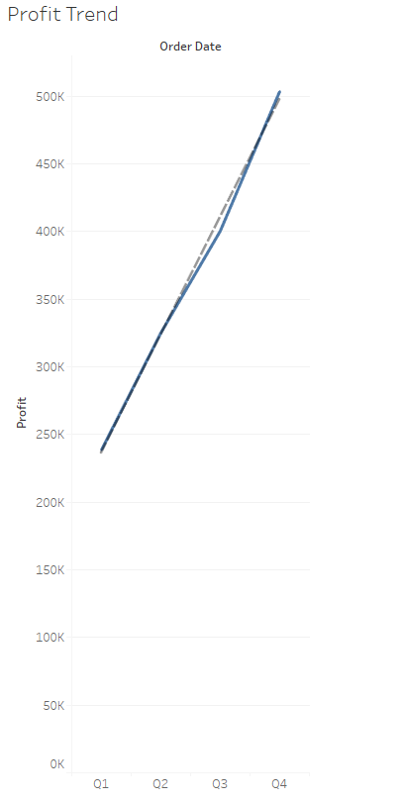

## Part V: Create the Dashboard

At this point, you have all the necessary views to achieve the objectives for your dashboard. Now, all that remains is to arrange them and enable the interactivity that's required to effectively tell the story:

1. Create a new dashboard by clicking the New Dashboard button  to the right of the existing worksheet tabs and the new worksheet button (or by selecting **Dashboard 🡪 New Dashboard** from the menu).
2. Rename the new dashboard as **Is Least Profitable Always Unprofitable?**.
3. At the bottom of the left sidebar, check **Show dashboard title**.
4. Add the views to the dashboard by dragging them from the Dashboard pane of the left sidebar and dropping them into the dashboard canvas. Arrange them in a useful and pleasing arrangement.
5. Do any necessary or desirable repositioning and resizing of the elements of your Dashboard. Use the Layout tab to adjust various display parameters.
6. Experiment with adding different filters. Select a Sheet in your Dashboard and choose the **Analysis 🡪 Filters** menu, and choose Filter.
7. Remove any filters you don’t want to keep (keep at least one) and make final adjustments to your Dashboard.
8. Add any annotations or other supporting material you would like.
9. Save and submit **LAB06.twb** and this **Word document**.